**ShopNest Store Capstone Analysis**

**By Amal Thomas**

ShopNest stands as the leading department store in the e-commerce marketplaces in Portugal. Serving as a seamless link, it connects small businesses from various regions in Portugal to channels, streamlining the process with a single point of contact. Through the ShopNest Store, these merchants can showcase and sell their products, with the added convenience of direct shipment to customers facilitated by ShopNest logistics partners. The provided data represents authentic commercial information that has undergone the process of anonymization.

1. **Top Categories by Total Price**

Identify and visually represent the top 10 product categories by total sales.

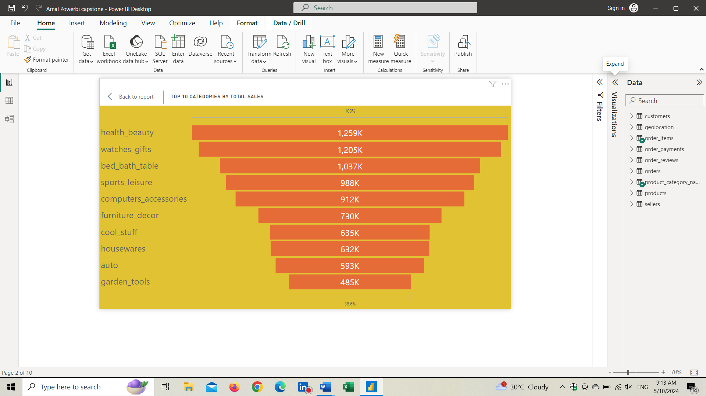

The purpose of this analysis is to identify and visually represent the top 10 product categories by total sales, with a focus on categories that have the highest sales compared to others. Understanding the performance of these top categories is essential for strategic decision-makings.

**Visual Overview**

The above visual clearly representing the amount of sales for each category and it representing only the top 10 categories. The visual represented through a funnel chart.

**Findings**

After analysing the data, the top 10 product categories by total sales, where sales are compared to other categories, are as follows:

* Health & Beauty
* Watches & Gifts
* Bed Bath & Table
* Sports & Leisure
* Computers & Accessories
* Furniture Décor
* Cool Stuff
* House wares
* Auto
* Garden Tools

**Insights**

The top 10 categories listed above shows literally higher sales compared to other product categories.

* Categories such as Auto, Garden Tools, and Health & Beauty seems to be frequently purchasing items based on regular use.
* Cool Stuff, Computers & Accessories, and Watches & Gifts represent different verities of products that customers purchase based on their interests.
* The performance of Housewares, Bed Bath & Table, and Sports & Leisure products deals with daily household works and enjoyment products.

1. **Delayed Orders Analysis**

Determine the number of delayed orders in each category. An order is considered delayed if the actual delivery date is later than the estimated delivery date.

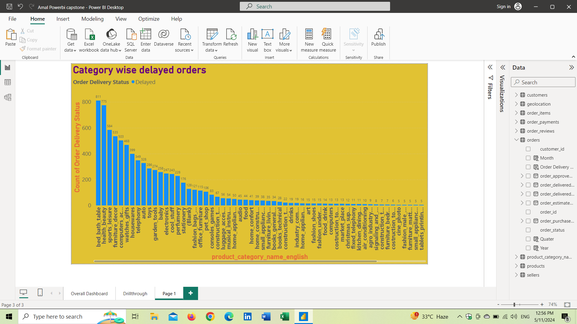

The purpose of this analysis is to determine the number of delayed orders in each category. A delayed order is defined as an order where the actual delivery date is later than the estimated delivery date. Through identifying product categories with a high number of delayed orders, the company can take proper actions to improve customer satisfaction.

**Visual Overview**

The above visual clearly represents most delayed product categories by number of orders delayed. All the products having slightly small changes from others. The chart used for visualization is bar chart. The product category is in X axis and Order delivery status is on the Y axis.

**Findings**

After analysing the data, some of the product categories by delayed product delivery, where delayed delivery items count is compared to other categories, are as follows:

* Bed Bath & Table
* Health & Beauty
* Sports & Leisure
* Computers & Accessories
* Furniture Décor
* House wares
* Watches & Gifts

**Insights**

* The analysis findings can be visually represented using a stacked column chart.
* Each bar represents a product category, and the height of the bar shows to the number of delayed orders in that product category.
* This visual representation allows us to compare the delayed delivery products that will help the company to focus on those products and provide more customer satisfaction.

1. **Monthly Comparison of Delayed and On-Time Orders**

Create a dynamic visual that compares the number of delayed orders to the number of orders received earlier for each month. Utilize the drill through cross-report feature to provide a detailed analysis of late and on-time deliveries.

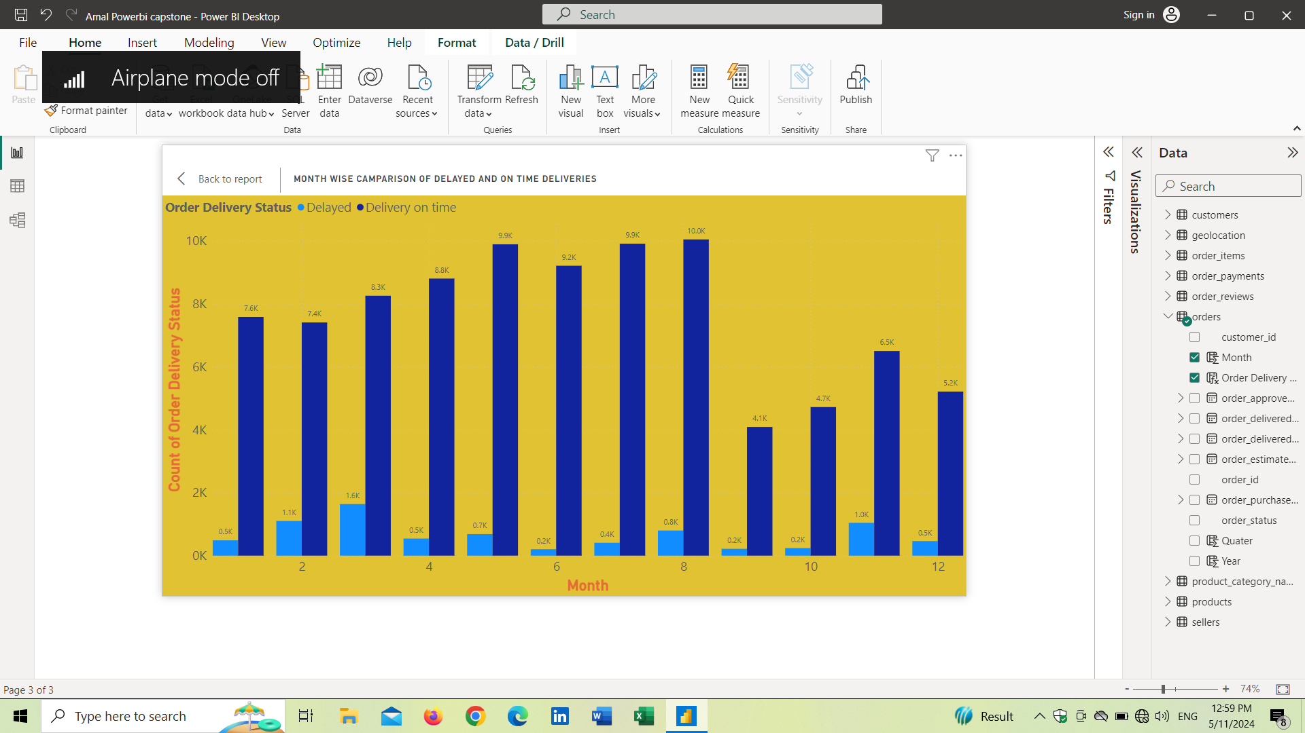

The objective of this analysis focuses on comparing the number of delayed orders to on-time delivered orders on monthly basis. By presenting the visuals of this comparison, we will get a clear idea about the trends and most fluctuating month details.

**Visual Overview**

The above visual clearly represents month wise number of delayed product categories and on time delivered product categories. We can find which months is having a greater number of delayed and on time delivered products from the above chart. We have created visual by using clustered column chart. The x-axis represents the months, while the y-axis represents the count of orders delivery status.

**Findings**

* June and October: June and October show the lowest number of delayed orders compared to other months. This could be because of a smaller number of factors are affecting the delivery time.
* August: On the other hand, August shows the highest number of on-time deliveries. It shows the smooth operation and efficient works from the team. Comparing to other months the delayed orders in August is not that much small.

**Insights**

**June and October (Lower delayed deliveries)**

Possible reasons for the lowest delay in June and October could include:

* Demand: June and October might be a period of lower demand or fewer distribution.
* Operations and Facility: Better operational facilities and smooth operations.
* External Factors: Smaller impact of external factors.

**August (Most number of on time delivery)**

Factors contributing to the highest number of on-time orders in August could include:

* Operations and Facility: Better operational facilities and smooth operations.
* Number of orders: Increased number of orders from the customers.
* Market conditions: Better conditions in market where a smaller number of factors are affecting the delivery time.

1. **Payment Method Analysis:**

Analyse the most frequently used payment methods by customers using a visually appealing representation, such as a pie chart or other suitable visuals.

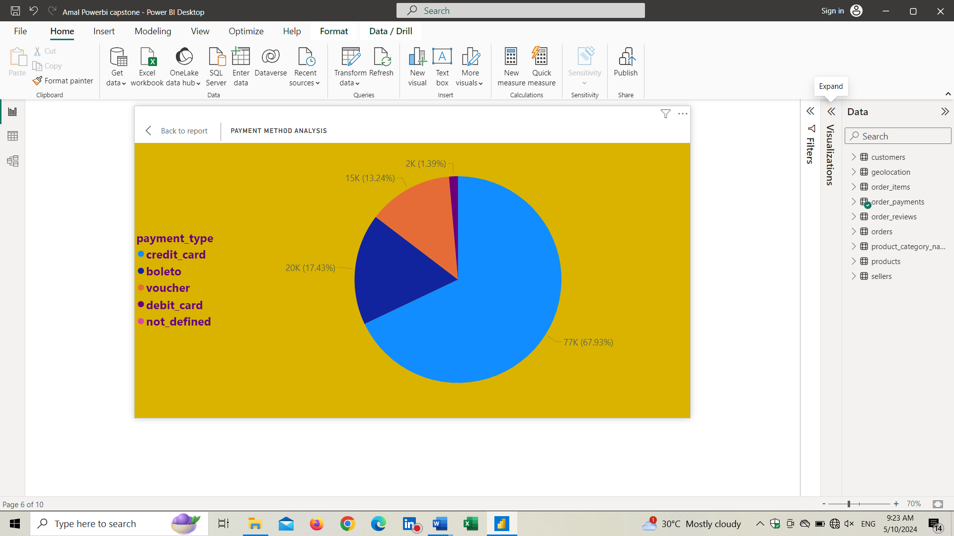

The objective of this analysis is to examine the most frequently used payment methods by customers. By understanding the distribution of payment methods, we all know that paymnet part is very cruicial in any business, if the customer is facing dissatisfaction with payment method then that will affect the fucture business from the customer.Here we are camparing the different payment methods.

**Visual Overview**

The above visual clearly represents the which type of payment system is having highest amount of use by customers. Here I have used a Pie chart to simply visualize the data.

**Findings**

* **Credit Card:**It clearly dominating the chart. People are more like to use credit cards for any payments ratherthan any other paymnet methods. Availability of more offers and the usage friendly should be the reasons
* **Debit Card:** Debit card usage is having the lowest usage amount comapring to other paymnet methods. This is may be due to lack of offers and lack ready available money.

**Insights**

The dominance of credit card payments shows that all the business sectors should establish the credit card paymnet system to ensure smooth and better payment facility satisfaction to customers to generate more future business.

Apart from credit card payments people are more like to use other payment methods such as baleto,voucher and debit card payments. Around 33% people are using these payment methods in this case. So establishmnet of all kinds of payments will be added advantages to any firm to generate and gain more customers,the mian point is payment part is very crucial and end process in any business.

1. **Product Rating Analysis**

Determine the top 10 highest rated products and the bottom 10 lowest rated products using a bar or column chart.

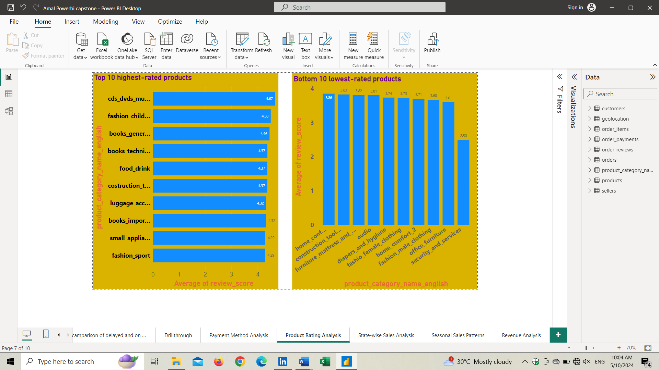

The product rating analysis aims to identify the top 10 highest-rated products and the bottom 10 lowest-rated products based on customer ratings. By visualizing this data, we can understand customer preference and more performing products.

**Visual Overview**

The above visuals clearly represent top 10 high rating and bottom 10 low rating products. A bar and column charts are used to present the visual. In the top 10 highest rated products chart, the ratings are in X axis and products are in Y axis. On the other hand, In the bottom 10 lowest rated products chart, the ratings are in Y axis and products are in X axis

**Findings**

**Top 10 Highest-Rated Products**

* The analysis reveals the top 10 products with the highest ratings, indicating customer satisfaction and positive feedback.
* These products are rated higher points due to the satisfying performance from the products.

**Bottom 10 Lowest-Rated Products:**

* The analysis identifies the bottom 10 products with the lowest ratings, showcasing the products needs to be consider for future developments and satisfying customer expectations

**Insights**

* Products are getting high ratings because of several reasons such as product performance, durability, user-friendliness, and exceptional customer service.
* Products are getting low ratings because of several reasons such as product design, quality, proper maintenance of the product and customer service protocols
* Use these reasons to enhance the product usage to increase the product ratings, this can consider as Product Development Strategies
* Product development and its wide spread completely depends upon the usage of customers. So, it’s important to satisfy and provide services that meets customers’ expectations.
* Product promotion is a key factor in high ratings, for the wide spread of products we should focus on promotions and that will lead to more usage and high ratings if it providing better performance.

1. **State-wise Sales Analysis:**

Identify and visually represent states with high and low sales, providing a clear understanding of regional sales performance.

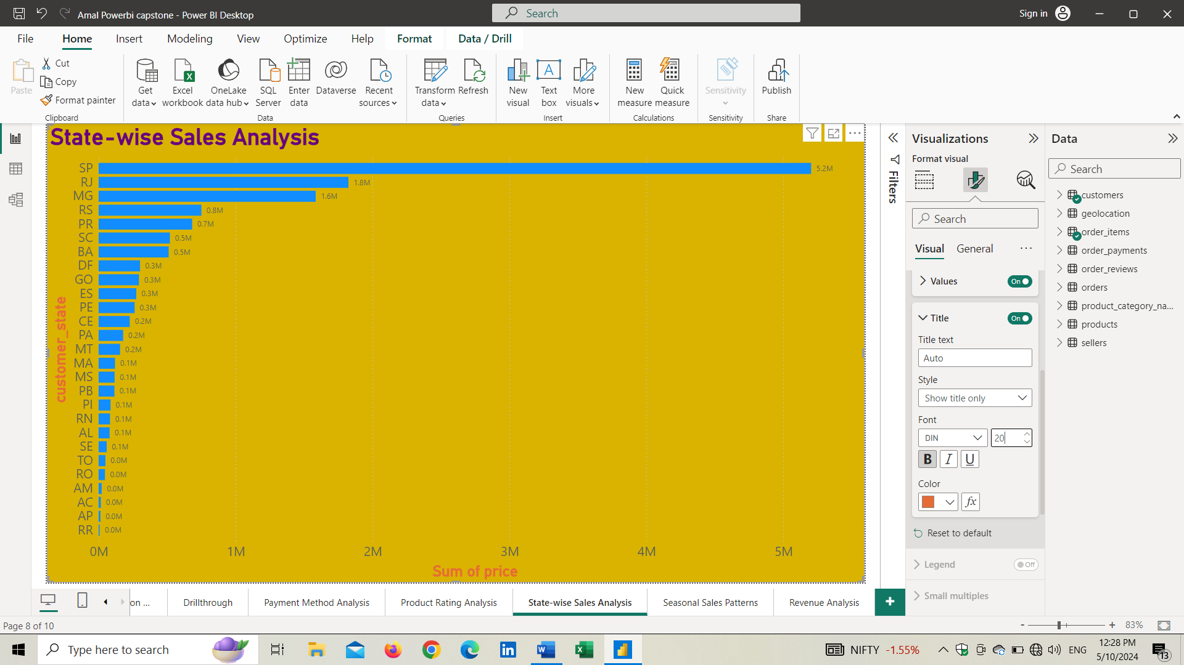

The above visual represent the state-wise sales analysis aims to provide insights into regional sales performance, highlighting states with high and low sales. This will give us an idea about which states is generating more business and less business and this can lead to planning for better market developments.

**Visual Overview**

The representation is on bar chart and Sum of sales (Price) is on X axis and state is on the Y axis. The longest bar is having higher sales and lowest bar is having smaller sales. The chart showing huge difference from 1st and 2nd states for the sum of sales.

**Findings**

* **Highest Sales in SP State:** The analysis reveals that SP state consistently generates the highest sales orders compared to all other states. This indicates the significance of SP state in contributing to overall sales performance.
* Some states also contributing higher sales comparing to others such as RJ, MG, RD, PR, SC and BA
* States with high sales contribute significantly to overall revenue, while states with low sales needs more strategies and proper management to increase sales

**Insights**

* Factors which lead to higher sales in SP State are, large customer base, favourable market conditions, effective marketing strategies, and strong partnerships with local businesses.
* States with low sales performance should be study and understand the potential opportunities for improvement. Targeted marketing campaigns, development of distribution networks are better ways to improve sales on these areas.
* Allotment of resources is a major factor, proper allotment led to better production and more sales, so it should be study and decide where we need more resources to generate more sales
* State wise promotions are major factor, identify which medium is more suitable for promotions in each state and follow the promotional activities based on that.

1. **Seasonal Sales Patterns**

Investigate and visualize any seasonal patterns (Quarterly) or trends in sales data over the course of the year.

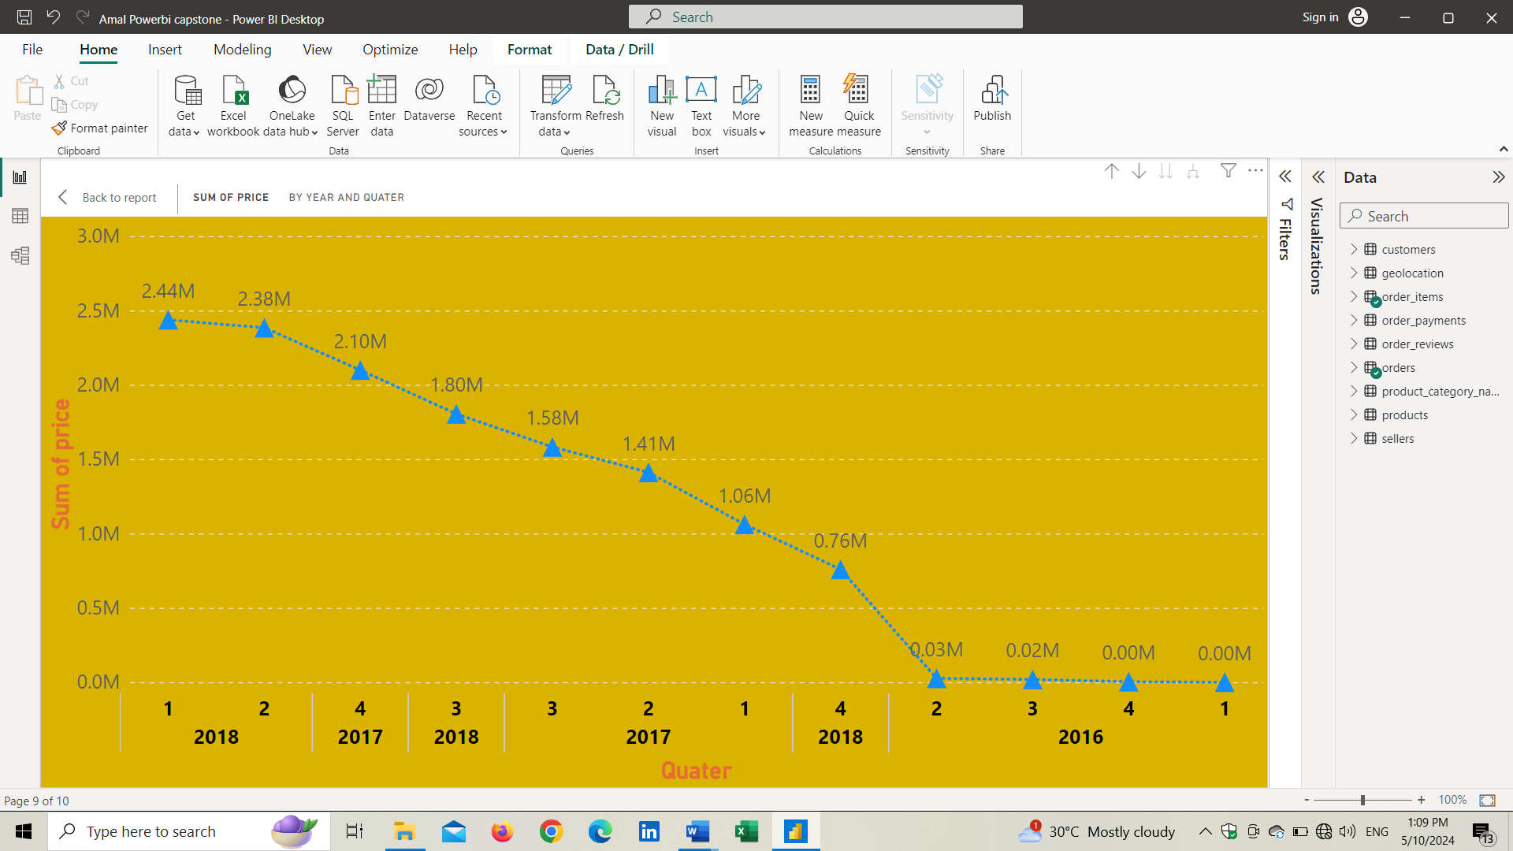

The analysis is to identify and visualize seasonal patterns and trends in sales over the course of the year. Understanding the changes over years will give us idea to plan more for sales like, marketing, product development and researches etc. Here we will explore every quarter sale in 2016, 2017 and 2018 years.

**Visual Overview**

From the above visual its clearly visible that the sales are increasing over the year and getting fluctuations in between quarters. The analysis findings are visually represented using a line. The chart represents sales change in every quarter of 2016, 2017 and 2017 years. X axis containing quarters and years while Y axis containing sales value.

**Findings**

* Quarter 1 of 2018 Sales is higher than other years.
* The total sales increasing over the years from 2016 to 2018
* When considering all the years Q1 in 2018, Q4 in 2017 and Q2 in 2016 are seems generating better sales.
* The data clearly states that high fluctuations are taken place in every year and quarters
* Q1 of 2016 is lowest sales generated season
* The factors influencing on these activities are holidays, promotional events, or seasonal demand for certain products.

**Insights**

* Q1 of 2018 is the peak period, so that would be the best to introduce new products to market.
* The best times of marketing, new offers and promotions are Q4 of 2018 and Q1, Q2, Q3 of 2017. This may lead to more sales in the 2018.
* The understanding of seasonal sales pattern would help in allocate resources effectively, optimize inventory levels, and anticipate fluctuations in consumer demand.

1. **Revenue Analysis:**

Determine the total revenue generated by ShopNest Store and analyse how it changes over time. Represent this information through suitable visuals to highlight trends and patterns.

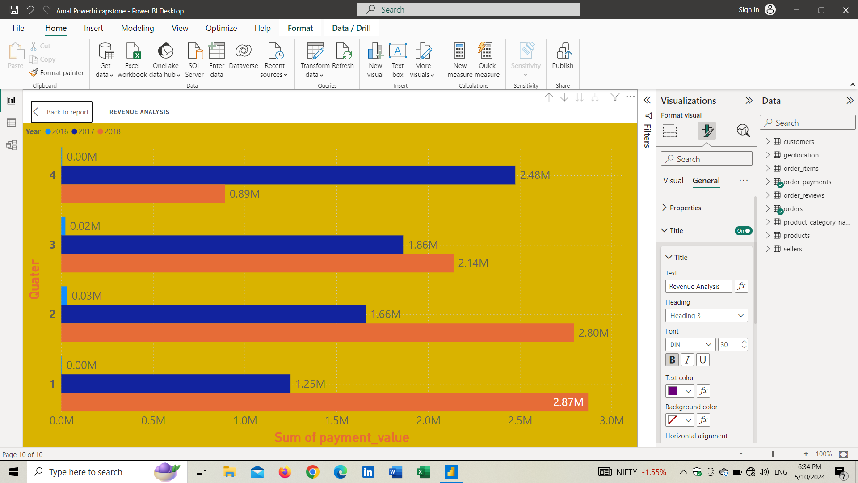

This analysis focuses on determining the total revenue generated by ShopNest Store and understanding how it changes over time. Identifying these values and getting a clear idea about changes will help us to know the store's performance, growth. In this analysis, we can see the total revenue over the 3 years such as 2016, 2017, and 2018.

**Visual Overview**

From the above visual its clearly visible that the total revenue changes over the years with 3 colours for 3 years and 4 quarters. The analysis findings are visually represented using a bar chart. On the X axis its sum of revenue and Y axis contains the Quarters and years Such as 2016, 2017, and 2018

**Findings**

* From the analysis we can find out the most revenue generated years and quarters. In the Q1, Q2, and Q3 the year 2018 is clearly having domination in revenue over other years.
* In the case of Q4 2017 is better than others.
* When we see the graph, we can get an idea that revenue increasing over the years so the company is in the development and better growth stage.
* There are some fluctuations happened in every quarter this could be influenced by factors such as seasonal demand for certain products, holiday sales events, or changes in consumer behaviour throughout the year.

**Insights**

* By analysing the revenue over years will help the company to focus on different intervals of time to generate more revenue and grow the business.
* By comparing the revenue with sales of products in the same period will help to terminate the unwanted products and generate more resources to achieve more sales though fast-growing products.
* This analysis clearly states company performance so they can plan and establish marketing and R&D research methods for the upcoming years.